**Noise pollution Monitoring**

**Objective:**

System uses air sensors to sense presence of harmful gases/compounds in the air and constantly transmit this data to microcontroller. Also system keeps measuring sound level and reports it to the online server over IOT. The sensors interact with microcontroller which processes this data and transmits it over internet. These AQMNs have multiple design objectives, including characterizing population exposure to pollutants, monitoring source impacts, measuring maximum and background pollutant concentrations, providing data for modeling purposes, and documenting air quality trends over time.

**Block Diagram:**

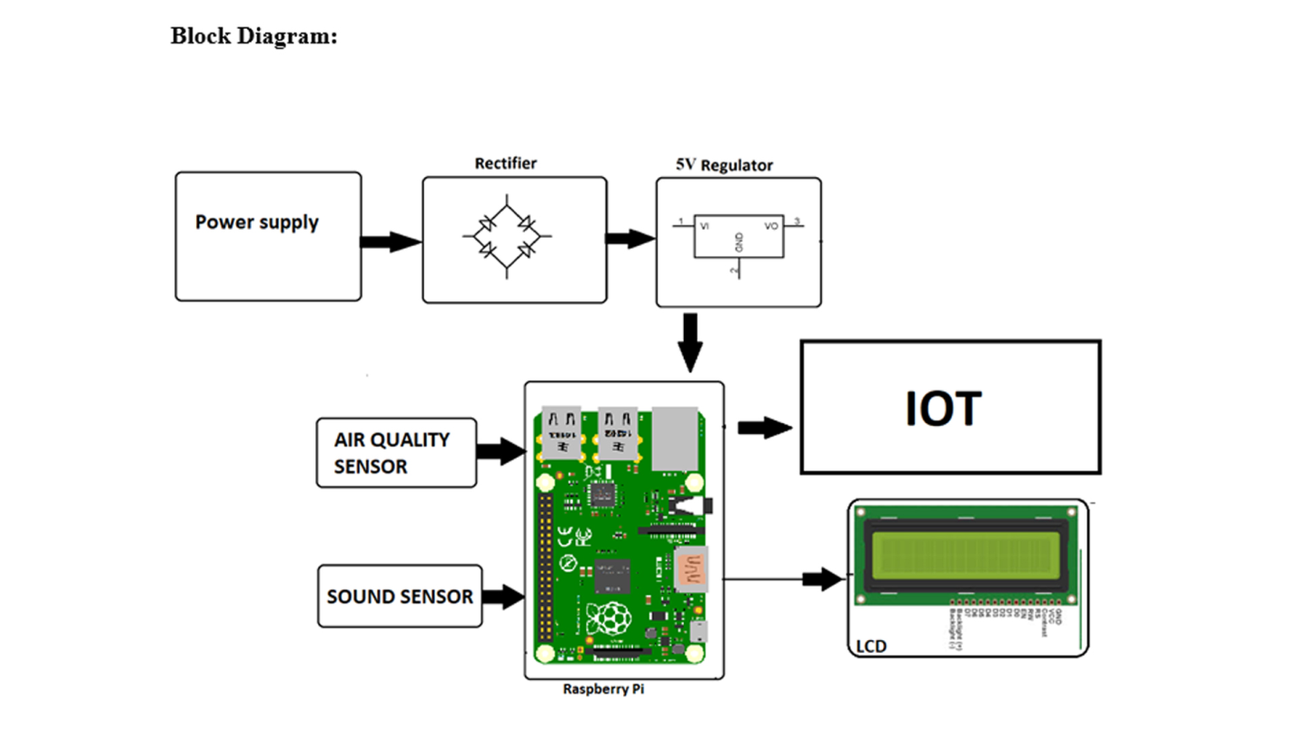

**Power supply:**

A power supply unit is used to provide stable electricity. The device converts and supplies electricity of the required voltage and frequency, excluding noise from the electricity obtained from an electrical outlet. Power supplies are classified by applications for available DC, AC, and output voltage ranges.

**Rectifier:**

Using a rectifier in the power supply helps in converting AC to DC power supply. Bridge rectifiers are widely used for large appliances, which can convert high AC voltage to low DC voltage.

**Regulator:**

This is the basic L7805 voltage regulator, a three-terminal positive regulator with a 5V fixed output voltage. This fixed regulator provides a local regulation, internal current limiting, thermal shut-down control, and safe area protection.

**Air Quality Sensor:**

Air quality sensors monitor gases, such as ozone, and particulate matter, which can harm human health and the environment.

**Raspberry pi:**

The Raspberry Pi is a low cost, credit-card sized computer that plugs into a computer monitor or TV, and uses a standard keyboard and mouse. It is a capable little device that enables people of all ages to explore computing, and to learn how to program in languages like Scratch and Python.

**Sound sensor:**

 The sound sensor is one type of module used to notice the sound. Generally, this module is used to detect the intensity of sound. The applications of this module mainly include switch, security, as well as monitoring.

**LCD:**

LCDs are commonly used for portable electronic games, as viewfinders for digital cameras and camcorders, in video projection systems, for electronic billboards, as monitors for computers, and in flat-panel televisions.

**Integration Approach:**

The IoT sensor used in our project will send data to the desired platform through secure and efficient manner. These sensors placed in a public area and it will collect the noise data and transmit to the established communication protocol over the internet or wireless networks. Strong security measures will protect the data during transmission ensuring accuracy and Privacy. This system enables real time monitoring noise pollution and promote noise conservation by providing accessible data to the community.

**Conclusion:**

This project present a valuable solution for promoting noise pollution in public places through a use of IoT technology. Higher levels of noise are hazardous and it is also difficult to make them escape in a closed environment. The increased levels of noise pollution in the environment have made it an urgent need to create awareness about the causes, effects, and prevention of noise pollution.